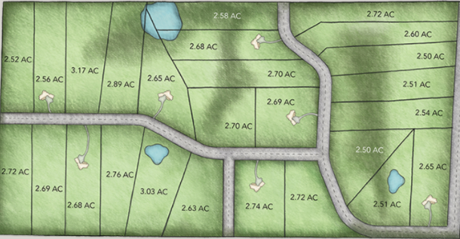  Harvest Bluffs  2.5 Acre premium home sites  Harvest Bluffs ~ Your Dream Home Awaits!  Harvest Bluffs is the South Metro’s newest most exciting acreage development located off Mushtown Rd (County Rd 87) South of County Rd 68 in Prior Lake MN. All the luxuries of living in the country with all the amenities of living in the City!  Harvest Bluffs is located within Prior Lake – Savage School District 719.  Lots sizes range from 2.5 acres to 3.71 Acres, some lots are heavily wooded for extra privacy and seclusion, while others offer open flat spaces ideal for pools and outbuildings. Up to 2,000 Sq. Ft. outbuildings are allowed per the protective covenants and Scott County.  Services are provided by Minnesota Valley Electric, Integra Telecom, and underground natural gas supplied to each property.  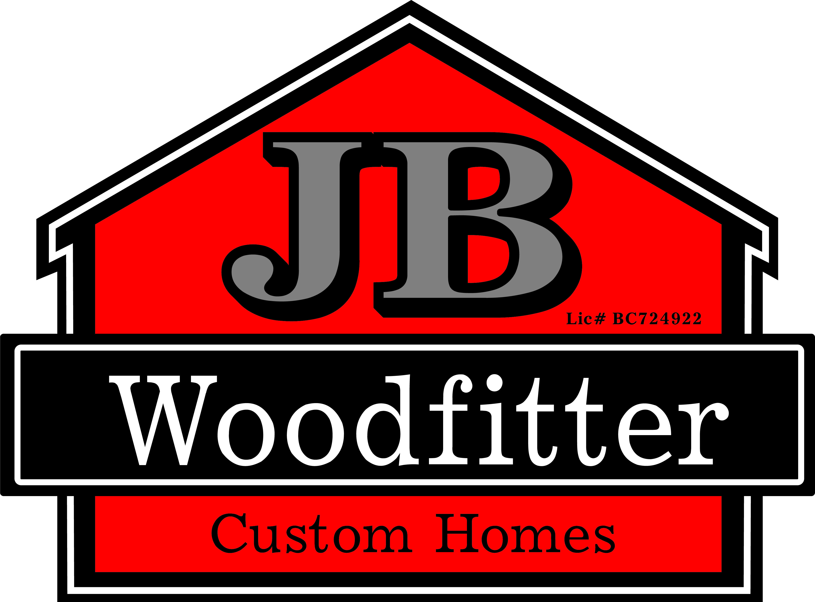 | 26 Beautiful partially wooded lots with rolling hills and water features  ────  Prior Lake – Savage Schools (Dist. 719)  ────  Protective Covenants and Architectural Approval Committee  ────  Just 4 miles South of Prior Lake  ────  Home Packages Starting in the low 700’s  Jb woodfitter homes  15815 Franklin Train SE,  Prior Lake MN, 55372  (952) 292-3523  JBWoodfitterhomes.com  Locally Owned, Family Owned, & Veteran Owned

